**Swinburne University of Technology**

**CSM80006-Engineering Project Management**

Assignment- 1

Week-1

10/08/2023

**Student Number: 104353339**

**Student Name: PRABAKARAN ANNAMALAI**

**CSM80006 Week 1 Tutorial A Part 1**

Identify a recently completed or ongoing current or future project that will start soon.

The objective of this work is to make metallic aluminium alloy 3D part using additive manufacturing methodology. The problem is to make any component made of aluminum by melting aluminium wire to molten form by using a graphite diffusion method.

1. **Briefly describe the need for the project (Need Assessment for Business Case)**

As the world continues to grow, the significance of manufacturing technology becomes ever more essential across diverse sectors, including industry, aerospace, medical, high-tech, marine, and consumer products. However, traditional manufacturing methods face limitations in coping with the increasing demand for complex designs, customizations, and efficient production processes. Therefore, there is a strong demand for innovative production engineering technologies to meet the diverse needs of customers. Hence, additive manufacturing technology is implemented in most of industries for their ongoing R&D innovation projects to make a prototype in quick time.

1. **outline the checklists for the project initiating group at inception stage of project.**
2. **Project objective:** The project's primary objective is to leverage the advantages of 3D printing technology to improve product prototyping and rapid manufacturing. The research aims to discover a method for creating metallic parts using aluminum wire or reel. Additionally, the study of metallic additive manufacturing techniques facilitates the exploration and development of new materials, making it easier to manufacture complex structures. This capability is highly beneficial for research and development teams working on new product development. Consequently, investigating metallic additive manufacturing technology holds great significance.
3. **Project Scope:** With the current metallic 3D printer, it is possible to manufacture components using only aluminum as the material. However, it is important to note that not all materials can be utilized with this 3D printer. Once the 3D printing process is completed, the final product necessitates quenching to restore its original mechanical properties and strength. This rapid cooling process facilitates the transition of the component from a higher temperature to room temperature.
4. **Project Team and Roles:**

Identify and appoint key project team members, including project manager and team leads. Define roles and responsibilities of each team member.

1. **Project Manager roles and responsibilities:** Identify key resources and assign them a task. Each sub task should be complied by a team lead.
2. **Project time:** Determine the project time needed for the project with available resources inside the organisation.
3. **Project Budget:** Estimate the budget and compare with organisation allotted budget. If exceeds, reorganise and plan accordingly.
4. **Quality Assurance:** Establish quality standards and procedures to ensure the deliverables meet the required quality levels. Define the process for quality control and assurance throughout the project.

**2) Suggest a suitable organisation structure for this project management to all deliver all intended deliverables and accomplish the project objective; (b) compare your recommend organisation structure with the organisation structure of any one of the stakeholders or project team (e.g. contractor organisation) involved in this project.**

The arrangement of an organization's components in its structure serves to relates and connect different elements, enabling the organization to attain its maximum level of performance. The selection of a specific structure significantly impacts the organization's ability to effectively execute its strategy and achieve its goals. It is crucial for leadership to grasp the attributes, advantages, and constraints of diverse organizational structures, as this knowledge aids in aligning strategic objectives.

**Compare your recommend organisation structure with the organisation structure of any one of the stakeholders or project team (e.g., contractor organisation) involved in this project.**

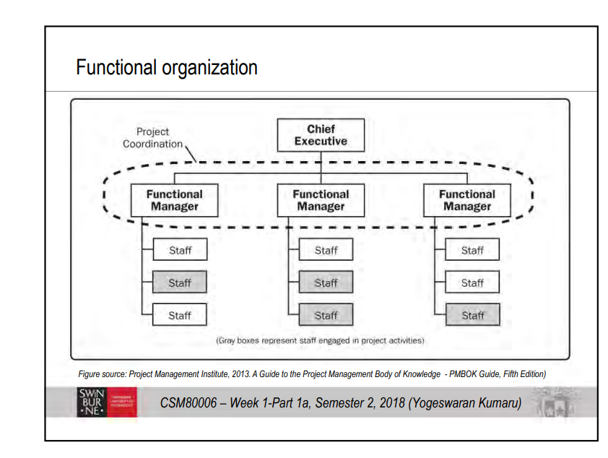

The above organisation chart taken from lecture notes for comparison of organisation structure.

**Question 3: What are project deliverables in this chosen case study project? B) your feedback and suggestion regarding achieving those project deliverables noted in the project charter.**

My organisation structure represents service industry which supports Information Technology (IT) activities. Once the project gets assigned to project manager, first they should understand the scope of the project. Later, need to share the statement of understanding with the client. Once the project approved, project manager responsibility is to prepare number of hours required to complete, number of technical resources and manpower to accomplish before the deadline with good quality. Additional resources can be deployed in case if it requires. Regular Scrum Meeting should be conduct by project manger to get to know about status of the project at every stage.